Koinobori

Probably the most popular display put on by WHKF is the Koi Carp. These are Japanese and traditionally flown on Tango no Sekku, Boy’s Day 5th May. In the late 1940s this was expanded to include Hinamatsui, girls day and became known as Kadomo no hi, or Children’s day.
The carp symbolise the male members of the family, as koi are very strong and swim courageously against the current often leaping out of the water. They therefore become a metaphor for hopes of the children’s parents.
They are usually flown on long poles outside houses; the top one that is always black represents the male head of the family and the second being red and slightly shorter representing the eldest son. Successively smaller koi represent the other sons.
Please note that while we fly seven of them this does not represent any significant family in WHKF.

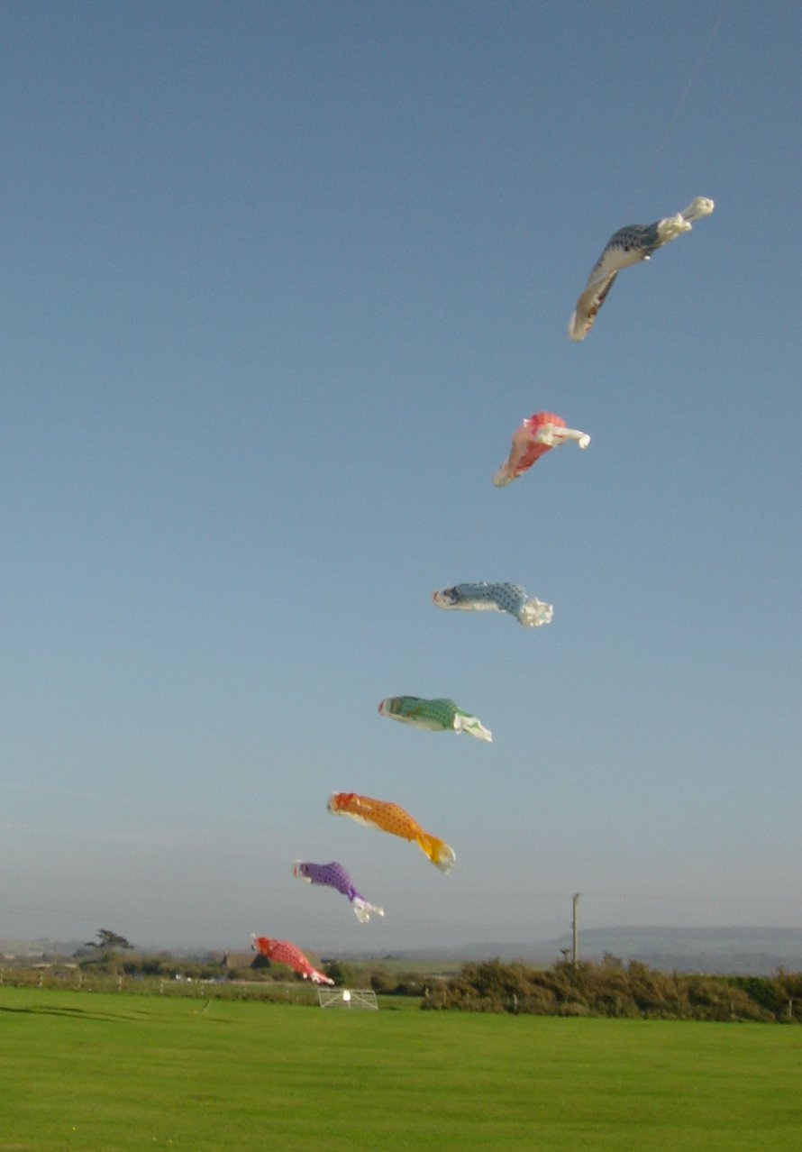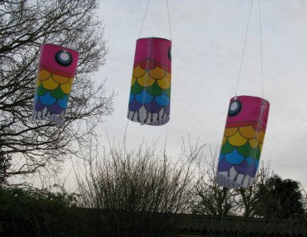

TO MAKE PAPER KOI
- Print Koiblank.jpg on A4 paper.
- Colour in all scales.
- Cut out along dotted blue line.
- Fold over long edge and stick on reverse.
- Use tape to reinforce points marked close to the eyes. Punch holes.
- Curve paper round and stick short edges together where shown.
- Tie a piece of thread about 1m long through the holes and tie a loop half way along.
- Hang from a tree, washing line or other high point where it can catch the wind.

